
hotel management system


NAME: HABIBA amir
student id: gh1036253
Module: Databases & Big Data
Professor: Alireza Mahmoud
GitHub Repository:
Video Demonstration:
Date: June 2026
Contents
Introduction: 4
Database Design: 5
Implementation: 8
SQL Queries and Results: 9
Challenges and solutions: 12
Conclusion and future work: 13

Introduction:
The objective of the Hotel Management System Database is to automate the entire process of managing a hotel. The Database is designed to hold the data of Customers, Rooms, Bookings and Payments.
The purpose of a database is to catalog hotel data and facilitate the retrieval of data using SQL queries. The database system is designed for hotel employees to control the reservations of customers, check the status and details of rooms, track bookings and payments.
The database is structured based on Customers, Rooms, Bookings and Payments tables.
Data integrity is maintained through the relationships of the various tables and enables the generation of the reports on total bookings, total revenue and Customer booking details.

Database Design:
The database holds four tables
- Customers.
- Rooms.
- Bookings.
- Payments.
The Customers table contains examples of customers with their name, email and telephone number.
The Rooms table includes detailed information about the room such as room type, room number and price.
The Bookings table includes information about the reservation and connects the customer to the room.
The Payments table includes payment information about the reservation.
All of these tables are connected with primary and foreign keys so the data integrity is maintained.

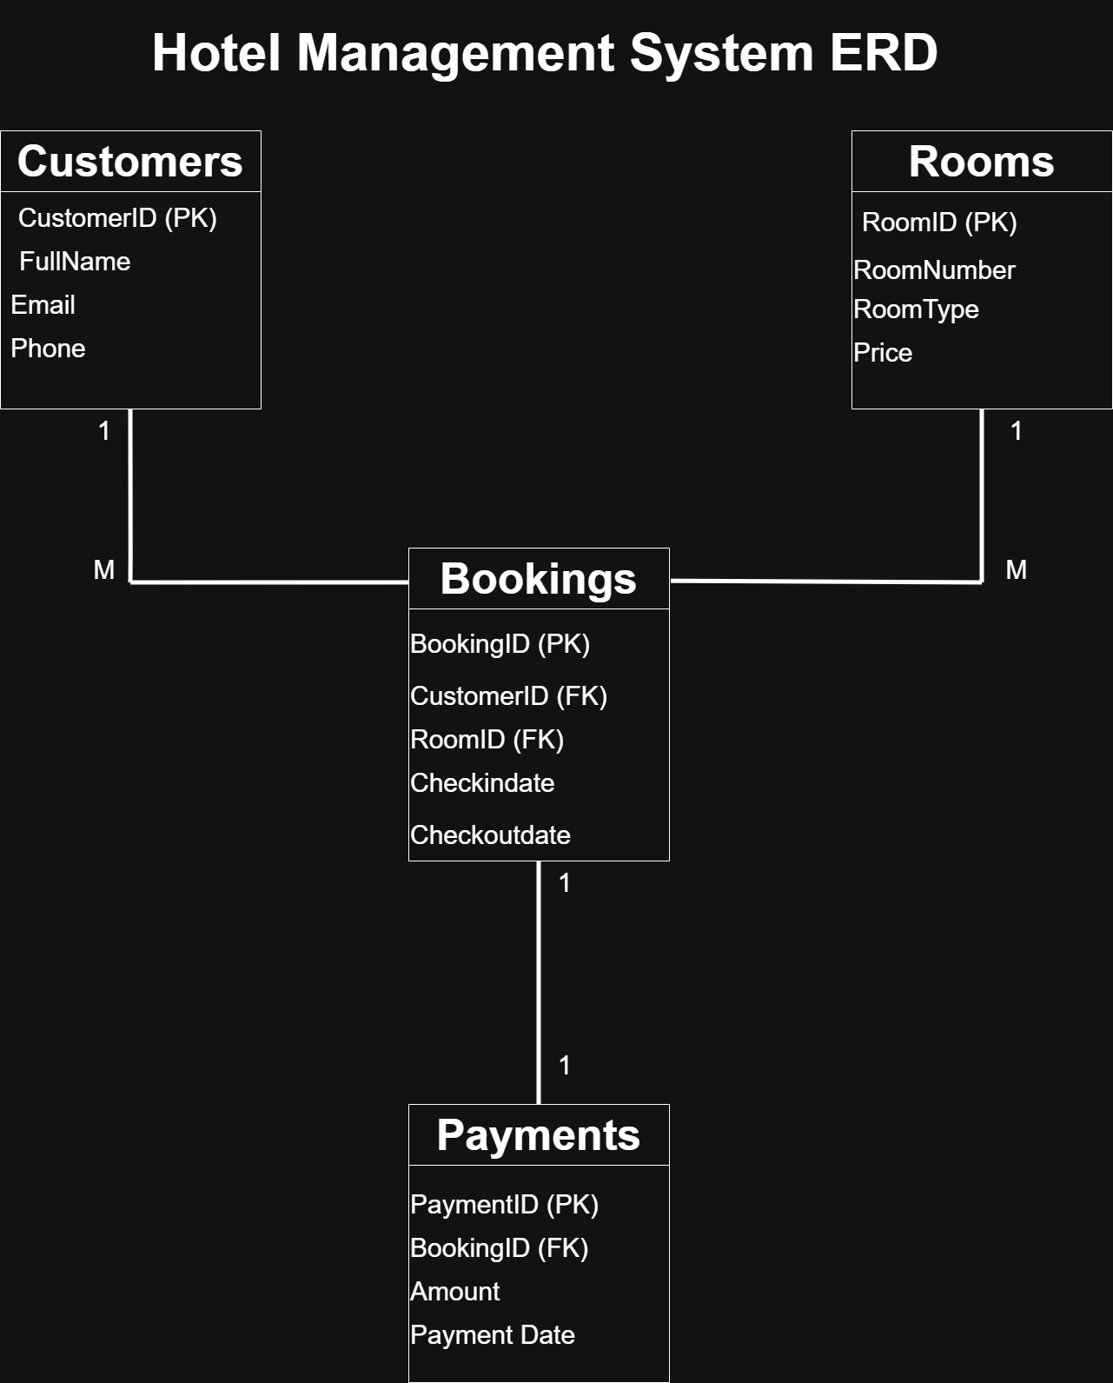
Figure 1: Entity Relationship Diagram (ERD) of the Hotel Management System.

Implementation:
- Customers Table
This table holds customer data, including name, customer ID, email address and phone number.
- Rooms Table
The rooms table contains information pertaining to the number, ID, type and price of each individual room.
- Booking Table
The Bookings table associates Customers and Rooms by means of Customer ID and Room ID.
- Payments table
The Payment table records payment information along with payment and booking identifiers.

SQL Queries and Results:
Query 1: Total bookings
SQL code:
SELECT COUNT (*) AS Total Bookings
FROM bookings;
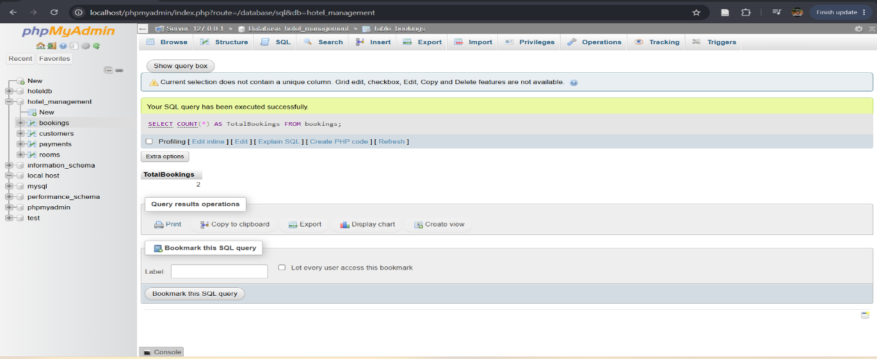

This query determines the total number of bookings in the database. The total is reported as 2 bookings.
Query 2: total revenue
SQL code:
SELECT SUM(Amount) AS Total Revenue
FROM payments;
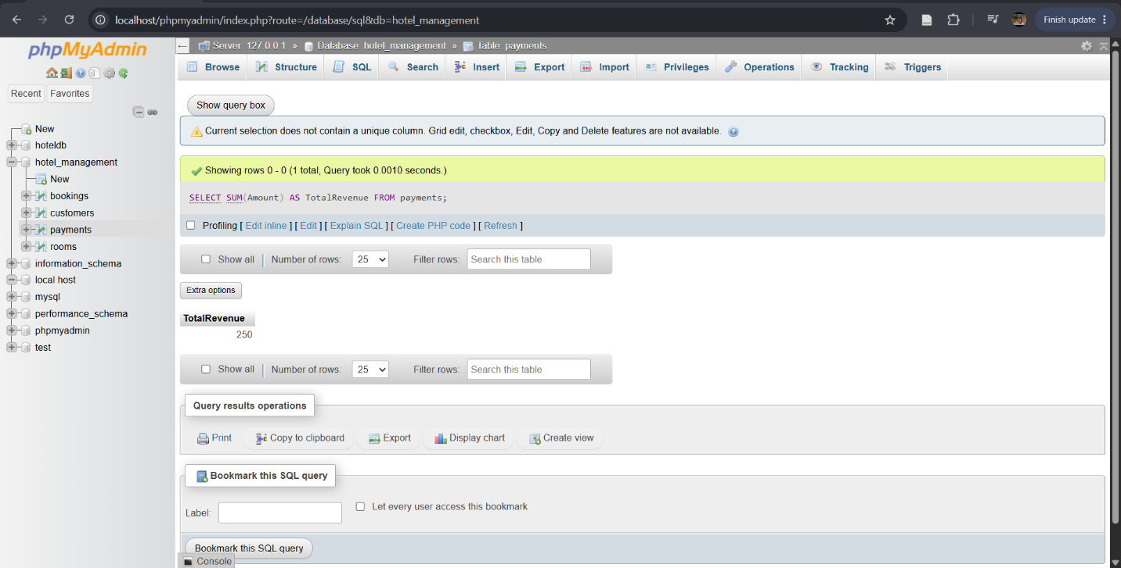
This query determines the total revenue from payments.
Query 3: Customer Booking Details
SQL Code:
SELECT
customers.FullName,
rooms.RoomNumber,
rooms.RoomType,
payments.Amount
FROM bookings
JOIN customers
ON bookings.CustomerID = customers.CustomerID
JOIN rooms
ON bookings.RoomID = rooms.RoomID
JOIN payments
ON bookings. BookingID = payments.BookingID;
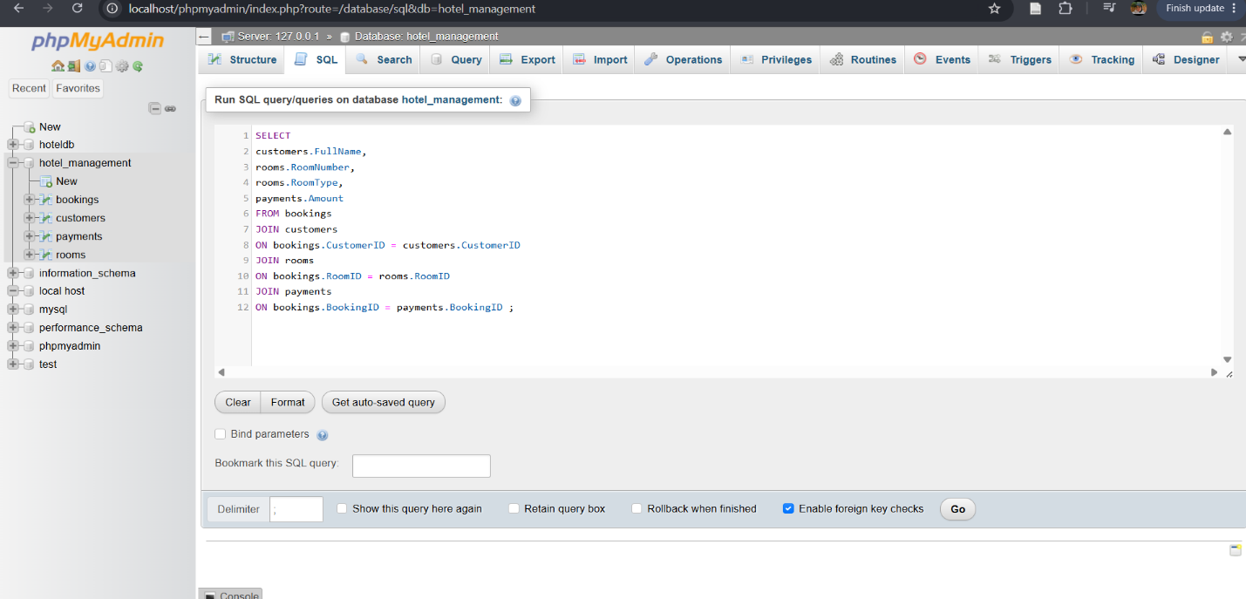
This query captures customer names and payment amounts and combines this data with information about room details by pulling information from multiple tables.

Challenges and solutions:

While developing the database for the Hotel Management System, a number of challenges arose. The most significant difficulty was with the construction of SQL JOIN statements due to mismatches in column names and in the relationships in the database between the tables. There were also a number of SQL statement construction related challenges that were due to the presence of syntax errors. All of these were resolved by the careful review of the table structure, the correct identification of the related primary and foreign keys and the iterative testing of the statements until the desired output was achieved.

Conclusion and future work:
The hotel management system database was successfully designed and implemented using MySQL and phpMyAdmin. The database contains four main parts in the table which are customers, rooms, bookings and payments. The relationship between the tables was created using primary and foreign keys to ensure data integrity. Several SQL queries were executed to retrieve useful information, like total bookings, total revenue and customer booking details. This project proved the practical use of relational databases and SQL for managing hotel operations efficiently.
For future work, additional features such as employee management, room availability tracking and online reservation functionally can be added to improve the system and make it more comprehensive.

